Monday | Tuesday | Wednesday | Thursday | Friday
Peer Support Group  1:00pm – 2:30pm | RISE Group (Regulate Internal Systems  and Emotions)  11:30am- 1:00pm  SMART Recovery Group  1:30pm- 3:00pm  Acupuncture Clinic  5:00pm – 7:30pm |  | Community Studio-Art Therapy  10:00am – 12:00pm  Osteopathy Student Clinic  1:00pm – 5:00pm | Osteopathy Student Clinic  9:00am – 1:00pm  Naturopathy Consultations  12:00pm – 2:00pm  Keeping Well in Community Group (KWIC)  10:00am – 11:00am
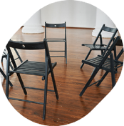



Bookings are essential for our Health & Healing therapies including Acupuncture, Naturopathy and Osteopathy.
RISE
Provides practical strategies to manage emotions, handle cravings and prevent relapse, supporting recovery and wellbeing.
Peer Support
A safe but challenging environment where you can gain insight and strength from shared experiences.
Community Studio
Experience the healing power of art in a group of supportive peers and our experienced Art Therapist.
Keeping Well in the Community
Support your recovery through Food as Medicine, nutrition and maintaining
healthy habits.

Please contact Reception to make an appointment. Please also contact us if you are interested in coming to
our Peer Support or Community Studio groups and programs and we’ll tell you more about joining.
SMART Recovery
Increase and sustain motivation for change, cope with cravings, and manage thoughts, feelings and behaviours
Call 03 9529 7955 (Monday to Friday, between 9:00am and 4:30pm) or email windana@windana.org.au.
Health & Healing therapies
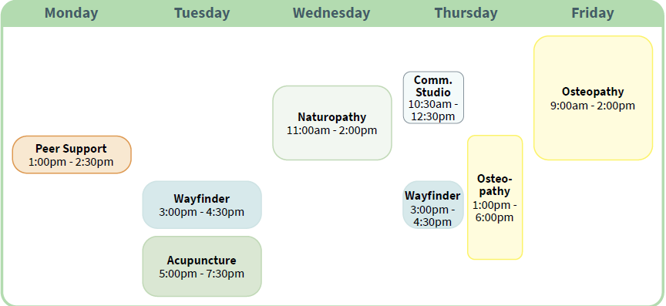
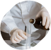


Osteopathy
Osteopathy works with the muscles, bones, joints and connective tissues
to promote health and wellbeing. Osteopaths consider the whole body when identifying sources of pain
and discomfort.
and nutritional upplements.
Naturopathy
Naturopaths take the time to understand your health and goals –
and work on tailored plans that can include lifestyle (healthy eating, sleep and movement), dietary advice, herbal medicine and nutritional supplements.
and nutritional upplements.
Acupuncture
This traditional practice uses very fine acupuncture needles at targeted points. It can be used in a holistic approach to manage pain and promote healthy sleep, digestion and regulate mood.

